

**The Impact of the Financial Market Disruption on the UK Economy**

Speech given by

Sir John Gieve, Deputy Governor, Bank of England 17 January 2008

1

All speeches are available online at [www.bankofengland.co.uk/publications/Pages/speeches/default.aspx](http://www.bankofengland.co.uk/publications/Pages/speeches/default.aspx)

# Introduction

These are testing times for the MPC.

The latest official figures for growth confirm the strength of the economy in Q3 with above trend growth in domestic demand and a growing current account deficit. But the evidence from surveys and other timely indicators is that growth is slowing quite sharply now, in part because of the rises in interest rates last year. That in itself might justify a progressive shift in policy – from restrictive to a more neutral stance. And the case for easing has been greatly strengthened by the disruption in global credit markets and in our own banking system which brings a risk of a deeper downturn.

However we have also seen a big rise in the world prices of oil and food. That is being amplified in the UK by a fall in sterling and is now coming through in our food, petrol, gas and electricity prices. These are likely to raise our inflation rate well above target in the coming months at a time when short term inflation expectations remain uncomfortably high.

This combination of upside and downside risks complicates our task of keeping inflation on track to meet the 2% target.

# Financial market disruption

The disruption of credit and money markets was set off by a deterioration in the US sub-prime housing market. This started to show up in increasing provisions in the 2006 accounts of banks which held them on balance sheet in a traditional way. But impairment charges of that sort would not have occasioned such ferment in international markets. That was the result of the impact on the new markets for structured credit such as Collateralised Debt Obligations (CDO’s)1 (Chart 1), which had developed to meet investors’ demand for higher yield. As forecasts of US sub- prime defaults mounted, it became clear that such products had introduced opacity and uncertainty into both the distribution and scale of losses.

1 Collateralised Debt Obligations are securities backed by a portfolio of fixed-income assets that

are issued in tranches of varying seniority. As default losses accrue to the underlying portfolio they are applied to the securities in reverse order of seniority. The main types of CDOs are those based on portfolios of leveraged bank loans (CLOs) and asset-backed securities (ABS CDOs).

The crisis played itself out in number of “lurches”, which were reflected in the movements in the ABX indices2 (Chart 2):

* Although the problems of the sub-prime market were obvious in mid- 2006, it wasn’t until January/February 2007 that the rising defaults led to mark downs in indices valuing the riskier tranches of the structured products and difficulties at a number of US sub-prime originators;
* in June, as losses began to appear in highly-rated tranches of so-called mezzanine CDOs, two heavily exposed Bear Stearns hedge funds collapsed; the rating agencies began to review their methodologies and started to downgrade securities, some by several notches;
* at the end of July, a SIV3 sponsored by IKB reported losses on sub- prime mortgage exposures and failed to raise funding in the commercial paper market, and in early August BNP Paribas temporarily suspended redemptions from a number of money market funds because of valuation problems; this provoked an ‘investors’ strike’ on mortgage-backed securities and the commercial paper that funded off-balance sheet vehicles holding them; in turn this led banks to hoard liquidity against potential calls on their committed lines, to a marked tightening of inter-bank markets and funding pressures on banks, including, of course, Northern Rock;
* after a brief lull in October, renewed doubts about the scale of the losses in the big international banks led to concerns about counterparty risk and sparked a renewed squeeze in the money markets with LIBOR spreads climbing back to levels experienced in August.

There are many lessons for markets and the authorities from this turmoil. First it underlined the critical importance of liquidity in managing and regulating banks. Second it showed up the limitations of the models which underpin the valuation and rating of structured products and the excessive weight that had been given to them not just by the naive or unwary, but by some of the most sophisticated players in financial

2 The ABX indices are baskets of 20 credit default swaps that provide insurance against default losses on securities of a given rating and vintage of issuance that are backed by home equity loans. The home equity loan category comprises mainly of sub-prime first mortgages, but also second

mortgages, mortgages with high loan-to-value ratios and home equity lines of credit

3 Structured investment vehicles are funds that issue short-term securities in order to invest in longer- term securities. The latter have typically comprised mainly of mortgage-backed securities and other asset-backed securities. Banks sponsored SIVs are managed by banks.

markets (including many of the sponsoring banks who underestimated the risks they were running in retaining super senior tranches). Third, it illuminated the adverse incentives that had been allowed to develop in the distribution chain for credit products including the strong incentives for originators to put quantity above quality, for the rating agencies to expand their scope as widely as possible, and for banks to use off-balance-sheet vehicles to finance structured credits. It may also reveal some flaws in the compensation schemes in banks. In some cases these incentives arose despite regulation, in others they were the consequence of faults in the regulatory system. Finally it showed again how measures of risk used by companies and regulators can be pro-cyclical, encouraging more risk taking at the top of the cycle and potentially exacerbating the downswing.

In the last few weeks, markets have been calmer. Liquidity pressures in short-term funding markets have eased, helped in part by the co-ordinated action by central banks to address elevated funding rates over the year end (Chart 3). And, as losses have been declared it has proved possible for a number of firms such as UBS, Merrill Lynch and Citigroup to attract new capital including from Sovereign Wealth Funds.

It is too early to declare the problem solved. The longer term bank funding markets remain relatively illiquid, many securitisation markets remain effectively closed (Chart 4), and general market sentiment remains fragile. Only a part of the total losses on sub-prime have yet been declared and not all the questions about the future of SIVs or the capitalisation of monoline insurers have yet been answered. The sub-prime chapter will not be closed for some months yet and there are still risks of re-ignition of the acute money market conditions we saw last month.

But there are grounds for hope that we are reaching the end of the beginning at least and that the key challenge is moving from stabilising the financial markets themselves to dealing with the impact on the wider economy.

# Macroeconomic impact

Judging that impact is not easy. Banking crises have typically reflected macroeconomic difficulties at home. Banks have lent too much and too cheaply at the top of the cycle and have then suffered from defaults when policy tightened and unemployment and failures increased. The most recent example in the UK banking sector was during the recession of the early 1990s when the major banks wrote off about 2.5%of their domestic loan book and tightened credit conditions, thus exacerbating the fall in property prices and in confidence. It has been estimated that

the effect of the tightening of credit conditions was to reduce UK output in 1991 by almost 2% relative to what it would otherwise have been.4 Of course, there was little monetary policy could do at that time to offset these effects because of Sterling’s ERM membership.

But the current crisis does not follow that pattern. It has come at a time when the performance of the UK economy has been unusually good. Over the past fifteen years the economy has experienced the most stable macroeconomic conditions on record with steady growth, low inflation and a declining trend in unemployment.5 For the most part the underlying balance sheet position of households and firms is robust and most indicators of financial fragility such as mortgage arrears, repossessions and corporate insolvencies are at low levels (Chart 5).

So the question is whether we can reverse into macroeconomic trouble starting from a banking crisis with its origins in the US housing market. Of course a marked slowdown in the US will diminish directly part of our exports. But two domestic transmission channels to consumption and investment will determine the size of the overall impact on our economy:

* the effects of credit constraints; and
* impact on expectations and confidence.

Credit constraints

With their own funding rates increasing and a reduction in their ability to distribute risk through securitisation, there is now clear evidence that UK lenders have begun to tighten lending conditions for households and firms. The Bank’s Credit Conditions Survey (CCS) of major UK lenders has identified a change in behaviour since the summer.6 Contrary to earlier expectations, lenders reported that the availability of secured credit to households had reduced noticeably over the three months to mid- December (Chart 6). Corporate credit availability was also reported to have been reduced significantly over the same period. A further reduction in the general availability of credit was expected over the next three months.

4 Young, G (1996), ‘The influence of financial intermediaries on the behaviour of the UK economy’, NIESR Occasional Paper No 50.

5 This is discussed in detail in the Bank’s memorandum to the House of Commons Treasury Committee’s inquiry into ‘The Monetary Policy Committee of the Bank of England: ten years on’, *Quarterly Bulletin*, 47(1), 2007Q1, 24- 38.

6 Credit Conditions Survey, <http://externalboeweb/publications/other/monetary/creditconditions.htm>

The survey suggests that lenders are both raising the price of borrowing and reducing the range of people and firms they are prepared to lend to. There has been a pick up in the average spread of quoted mortgage rates over the appropriate funding rate in recent months (Chart 7). There has also been a fall in the number of mortgage products available for credit-impaired borrowers (Chart 8).

The first impact of the tightening in secured credit conditions is being felt in the property markets and lower demand for assets but there will also be direct effects on activity. Although only a minority of households may be credit constrained they are probably sufficient in number to depress household spending somewhat, possibly reversing a little of the decline in the saving ratio seen since the early 1990s (Chart 9). In a similar way a tightening of corporate lending conditions will affect some companies’ investment. The Deloitte CFO survey taken in early December finds that 20% of firms expect the recent credit market events to have a negative impact on their capital spending in 2008.7

This tightening of credit conditions would be exacerbated by any further weakening in the financial position of banks due to a slowdown in the wider economy. Slower growth and a rise in unemployment in particular would lead to higher loan defaults.

There are signs that this is already happening in consumer lending in the US. Weakening property prices would reduce the amount that lenders could realise in the event of default. With pressures on their capital and new capital expensive where it is available, banks are likely to attempt to increase their margins and to slow down new lending, thereby reducing their capital requirements, for example by tightening non- price terms and conditions on new loans.

One factor which regulators are watching carefully at present is the impact of the shift this month to the Basle II system of capital requirements for European banks. While Basle II improves on its predecessor and removes many undesirable incentives, it retains some procyclical features and any transition needs to be managed carefully.8

7 The Deloitte CFO Survey: Benchmarking Corporate Financial Attitudes, 4 January 2008.

8 Benford, J and Nier, E (2007), 'Monitoring cyclicality of Basel II Capital Requirements', Financial Stability Paper No. 3 (December 2007), Bank of England.

The impact on expectations and confidence

The other channel by which the financial market turbulence is likely to have macroeconomic effects is by prompting more cautious behaviour by households and firms. This might simply reflect uncertainty about the future. Firms may temporarily postpone investment because of greater uncertainty about the future path of demand. We saw an effect like this after 9/11 for example. But it might also reflect a revision by households and firms about the sustainable path of income and wealth in the coming years. The change in expectations may reflect the higher costs of borrowing and a higher risk of unemployment.

Again a reduction in confidence about future growth may lead directly to lower consumption and investment. It is also likely to affect equity and property markets. Potential buyers may decide to wait before purchasing if they sense that there is a chance that prices may fall. Such behaviour can be self-fulfilling.

There is no doubt that the housing market has been weakening significantly in recent months and the trend is more advanced still in commercial property markets where prices are falling rapidly. It is widely assumed that weakening property prices will also depress consumption. The Bank has tended to be sceptical of this mechanism. 9 While property prices and spending tend to move together, that doesn’t prove that one causes the other. Both may result from changes in income and expectations of future income.10 Indeed, in the same way as you can’t have your cake and eat it, it is not clear that a general increase in house prices does create extra spending power for the population as a whole. Owners who expect to remain in their current house for a long time cannot also spend their housing wealth and the benefits to those trading down are broadly offset by the costs to those trading up. While older owners may be richer and believe they can support a more expensive lifestyle, the rise in prices will show through in higher rents and larger deposits for those wanting to get on the ladder.

9 This view is discussed fully in Benito, A, Thompson, J, Waldron, M, and Wood, R (2006), ‘House prices and consumer spending’, *Bank of England Quarterly Bulletin*, Summer, pp. 142-154.

10 Some household level evidence for this view is given by Attanasio, O, Blow, L, Hamilton, R, and Leicester, A (2005), 'Consumption, house prices and expectation', Bank of England Working Paper No. 271

But even if there is not a strong causal connection between house prices and consumption through a wealth channel, there may nevertheless be a significant collateral channel. When house prices fall, the amount of housing equity and hence collateral at homeowners’ disposal decreases. This will tend to delay spending as lenders are willing to lend less or lend on less favourable terms to those who have little or no housing equity. That channel should have become less important in recent years. This is because most homeowners have substantial equity in their homes which would not be materially affected by relatively modest changes in house prices.11 This may help to account for a decline in the correlation between real house price growth and consumption since the beginning of the decade (Chart 10).

An analogous collateral channel may operate in the corporate sector. Declines in commercial property prices will weaken corporate balance sheets and this could affect corporate spending if lenders raise the cost of borrowing to affected companies. This effect is likely to be particularly pronounced among commercial real estate companies.

# Inflation and energy prices

In these ways the losses in credit markets are already contributing to slowing growth; the questions are by how much and for how long? The danger that they could turn a necessary modest slowdown into a deeper and more painful downturn is clear and, of course, that would dampen inflationary pressures. That was a key factor in my decision to vote for a cut in rates in November and December.

But the current situation is complicated by emerging upside pressures on prices. This inflationary pressure is coming largely from outside the UK, reflecting in part increased demand from countries like China where output growth has been both rapid and commodity intensive. That has led to renewed strength in commodity prices (Chart 11), with oil rising as high as $100 a barrel and some agricultural foods reaching record highs in dollar terms. This has already increased the prices of

11 Evidence on housing equity is presented in Waldron, M and Young, Y (2006), ‘Household debt and spending: results from the 2007 NMG Research survey’, *Bank of England Quarterly Bulletin*, Winter, pp. 512-21.

imported goods, and that effect has been amplified recently by the fall in sterling. In turn, it is putting upward pressure on the sterling prices set by domestic producers for crude oil and wholesale gas and electricity. And, in contrast to the past, demand from emerging economies may mean that commodity prices prove resilient to slowing growth in the industrialised economies.

The appropriate monetary policy reaction to upside pressures on prices coming from outside the economy (such as an energy price shock) depends on how households and businesses react to that shock - in other words, on so-called ‘second-round’ effects. A key determinant of those effects will be the impact on inflation expectations. If households’ and businesses’ expectations of future inflation rise following the initial price shock, pressures for compensating rises in wages and prices are much more likely. Inflation expectations are difficult to measure, but surveys of households’ expectations have picked up since early 2005 (Chart 12). This partly reflects the rise in inflation during 2005-06. But expectations have remained elevated during 2007 despite the easing in inflation in the second half of the year.

# Conclusion

After a long period of stability, we have experienced a major financial shock that has reverberated through the banking sector in all the advanced economies. It has calmed recently, but we should expect a prolonged period of discomfort for individual banks and the financial system as a whole. Unusually, this shock was not the result of bad loans at home but it will have an impact on growth through tighter credit constraints and by influencing expectations and confidence. We cannot be sure how large those effects will be but they pose a serious downside risk to growth. To make matters more difficult, we face a sharp rise in inflation in coming months as a result of rising commodity prices worldwide and a fall in our exchange rate.

In reaching our decisions, the MPC always looks not just at the central projection for the economy but at the risks on either side. That will require not just difficult judgements but careful explanation in the months ahead.

**Chart 1: ABS CDO issuance**

CDO^2

Mezz ABS CDO HG ABS CDO

Source: Citi

1999

2000

2001

2002

2003

2004

$ billion

225

200

175

150

125

100

75

50

25

0

2005

2006

2007

**Chart 2: Prices of US sub-prime mortgage credit default swaps(a)**

US$

110

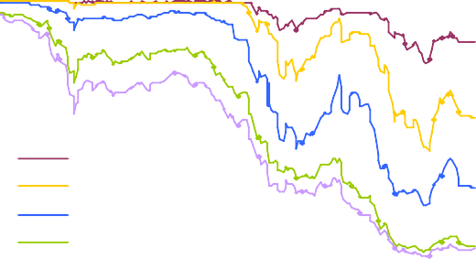

AAA AA A BBB BBB-

100

90

80

70

60

50

40

30

20

10

0

Jan Apr Jul Oct Jan 2007 2008

Source: Bank calculations.

(a) ABX.HE 2006 H2. Each index references 20 home equity loan (HEL) ABS of indicated rating issued in 2006 H1. Sub-prime loans form the vast majority of the collateral backing HEL ABS.

**Chart 3: 3-month LIBOR spreads over expected policy rates**

**Chart 4: RMBS issuance by all UK resident issuers**

Basis points

120

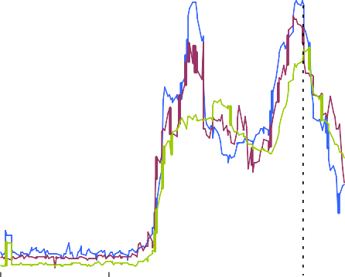

(b)

Sterling

US dollar Euro

100

80

60

40

20

£ blns (three month rolling sum)

60

50

40

30

20

10

0

0

Apr Jul Oct Jan

2007 2008

Source: Bloomberg.

00 01 02 03 04 05 06 07

Source: Dealogic. Data to end-December 2007

1. 3-month LIBOR spreads over 3-month overnight index swap (OIS) rates.
2. Coordinated central bank measures announced (12th Dec 2007).



|  |  |
| --- | --- |
| **Chart 5: Mortgage arrears and possessions rates** | **Chart 6: Household secured and corporate credit availability** |
| Percent Percentage greater than 3 months in arrears  0.9 7  0.8 6  0.7  0.6 5  0.5 4  0.4 3  Possessions (LHS)  0.3 2  0.2  Arrears (RHS)  0.1 1  0 0  1990 1993 1995 1998 2001 2004 2006 | Net percentage balances(a) Easier  credit  Household 30  Secured Corporate 20  10  0  -10  -20  -30  -40  -50 Tighter  credit  -60  Q2 Q3 Q4 Q1 Q2 Q3 Q4 Q1 |
| Source: CML  Back cast data before 1994 | Reported change, past three months Expected change, next three months  Source: Bank of England Credit Conditions Survey |
| **Chart 7: Quoted mortgage spreads** | **Chart 8: Mortgage product availability** |
| Basis point spread to funding rate(a)  250  SVR 200  150  Bank Rate Tracker  5 yr fixed 100  50  0  2 yr fixed  -50  2001 2002 2003 2004 2005 2006 2007 | Thousands Credit impaired 10  Prime 9  8  7  6  5  4  3  2  1  0  Feb Mar AprMay Jun Jul Aug Sep Oct Nov Dec End  Dec |
| Source: Bank of England.  (a) SVR mortgages spread over one month lag of Bank Rate; Tracker mortgages spread over Bank Rate; 2 yr, and 5 yr fixed rate mortgages spread over one month lag of 2 and 5 year swap rates. | Source: MoneyFacts. |

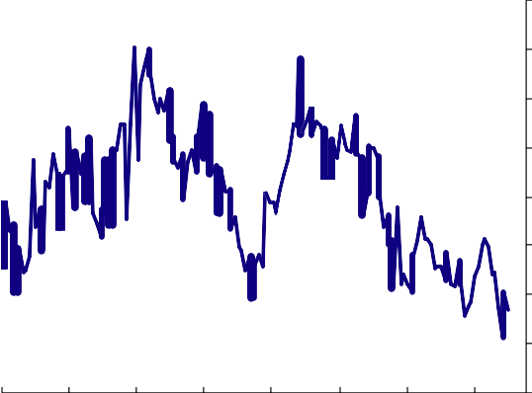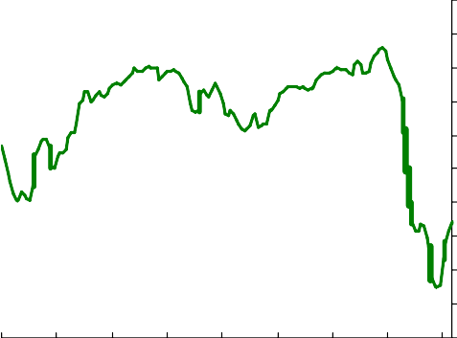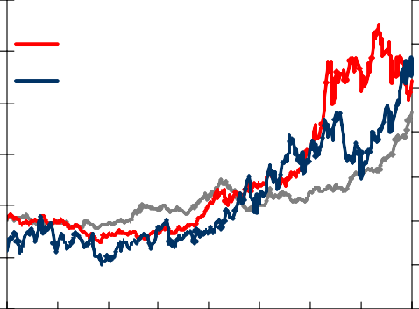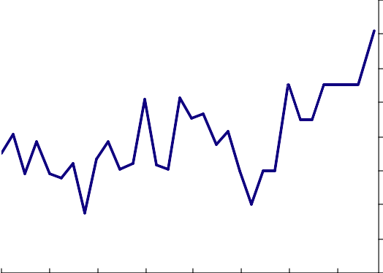

|  |  |  |  |  |  |  |  |  |  |  |
| --- | --- | --- | --- | --- | --- | --- | --- | --- | --- | --- |
| **Chart 9: Household saving ratio** | | | | | | | | | **Chart 10: Correlation between growth in house prices and consumption** | |
|  |  |  |  |  |  |  |  | 16% | Rolling ten-year correlation coefficient between real annual house price inflation and consumption growth 1.0  0.9  0.8  0.7  0.6  0.5  0.4  0.3  0.2  0.1  0.0  1966 1971 1976 1981 1986 1991 1996 2001 2006 | |
|  |  |  |  |  |  |  |  | 14% |
|  |  |  |  |  |  |  |  | 12% |
|  |  |  |  |  |  |  |  | 10% |
|  |  |  |  |  |  |  |  | 8% |
|  |  |  |  |  |  |  |  | 6% |
|  |  |  |  |  |  |  |  | 4% |
|  |  |  |  |  |  |  |  | 2% |
|  |  |  |  |  |  |  |  | 0% |
| 1970 | 1975 | 1980 | 1985 | 1990 | 1995 | 2000 | 2005 |  |
| Source: ONS | | | | | | | | | Source: Bank calculations. | |
| **Chart 11: Commodity prices** | | | | | | | | | **Chart 12: General public inflation expectations** | |
| US dollars per barrel Index, 2000=100  120 Economist food index (rhs) 350  100 Economist metals index(rhs) 300  Brent oil spot prices (lhs) 250  80  200  60  150  40 100  20 50  0 0  2000 2001 2002 2003 2004 2005 2006 2007 2008 | | | | | | | | |  | **3.2** |
| **Bank/NOP** | **3.0** |
|  | **2.8** |
|  | **2.6** |
|  | **2.4** |
|  | **2.2** |
|  | **2.0** |
|  | **1.8** |
|  | **1.6** |
| **Feb- Feb- Feb- Feb- Feb- Feb- Feb- Feb-** |  |
| **00 01 02 03 04 05 06 07** |  |
| Source: datastream and bank calculations | | | | | | | | | Source: Bank of England/NOP public attitudes to inflation survey. | |